Spencer, Jeremy (from Great Southern Bio Logic website)
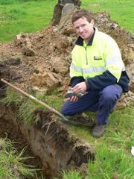
CALM Dwellingup field cadet course/Bunbury Tech 1990-91. Bachelor of Marine Science and Environmental Science, Murdoch University.
Environmental Scientist, Coffey Environments 2006-10. Director of Great Southern Bio Logic 2010-.
Area leader, Geographe Capes, Department of Water 2005-06.
Accredited Phytophthora dieback interpreter DEC 2010.
Great Southern Bio Logic is a local Environmental consultancy established in the Great Southern in 2010. Directors Jeremy and Meredith Spencer each have many years experience in the field of environmental management, with backgrounds as officers with the former Department of CALM and current Department of Environment and Conservation (DEC).
Jeremy has many years experience in the private sector working as an Environmental Scientist, specialising in contaminated sites. He is also a DEC accredited Dieback Interpreter and former Senior Regulatory Officer with the Department of Water. With such a broad spectrum of skills and experience, Jeremy can perform a wide range of professional environmental services, ensuring satisfaction of project requirements and regulatory conditions.

